**Integration Test Set up**

**Please find below the various steps involved in setting up integration test in local machine:**

1. Once the project is cloned in our local machine from Git repository following steps need to be done:

* Update the HANA DB URL, User ID and Password in the “connection.properties” file present at:

Servers--> config_Master🡪Connection_data

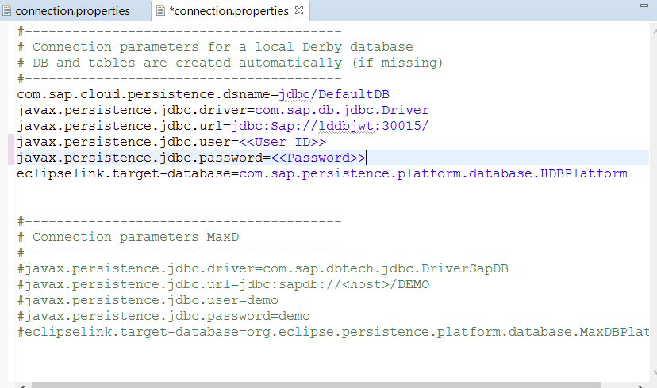

* User ID should be created in JWT system for Integration test (Marius can create the user Id with ready only access)
* Update the above URL, User ID and Password in the “connection.properties” file present inside “Integration.tests”

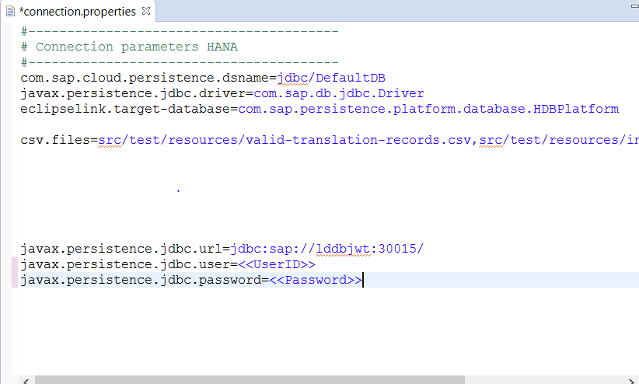

1. In order to run the integration test, we will run a batch file. We need to update the following in the batch file:

* Update the NEO_SDK Path pointed to the location where NEO SDK is installed in your machine.
* Update project path everywhere in the batch file
* Update JWT system URL , User ID and Password in the batch file
* Create myScripts\hugo.txt in c drive and update the path in the batch file
* Install SED.exe in C drive and update the path in batch file
* In the last line of the batch file i.e.,

mvn -f C:\Users\C5228092\git\com.sap.translationservice_30July\com.sap.translationservice.parent\pom.xml -B -e clean install -P integration-test,it-developer -Dbrowser=firefox

Update the profile in which we are running the integration test

The Sample Batch file is attached



1. To Run batch file, we follow following steps:

* Go to Command prompt
* Go to the path where batch file is placed
* Run the batch file

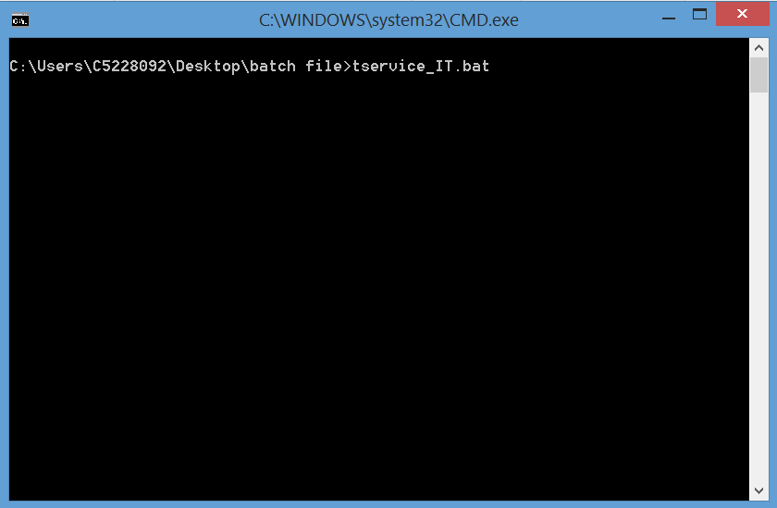

1. In case there are failures then we can verify in the log files placed in the below paths:

**\com.sap.translationservice.integration.tests\target\surefire-reports**

**\com.sap.translationservice.integration.tests\target\server\log**